**How to install Strava App**



This document covers how to install **Strava app** on your smartphone. The **Strava app** is a smartphone application designed purposefully as a fitness tracker for running, cycling and other high-performance activities. It is used for tracking routes as well. Here, we are adapting this application to track our route the field trips in London and Barcelona.

**Instructions for installing Strava app [You can watch a video for a guided demonstration (**[**CLICK HERE**](https://web.microsoftstream.com/video/a2822f80-c53c-4a10-b1d5-7622ac954373)**)]**

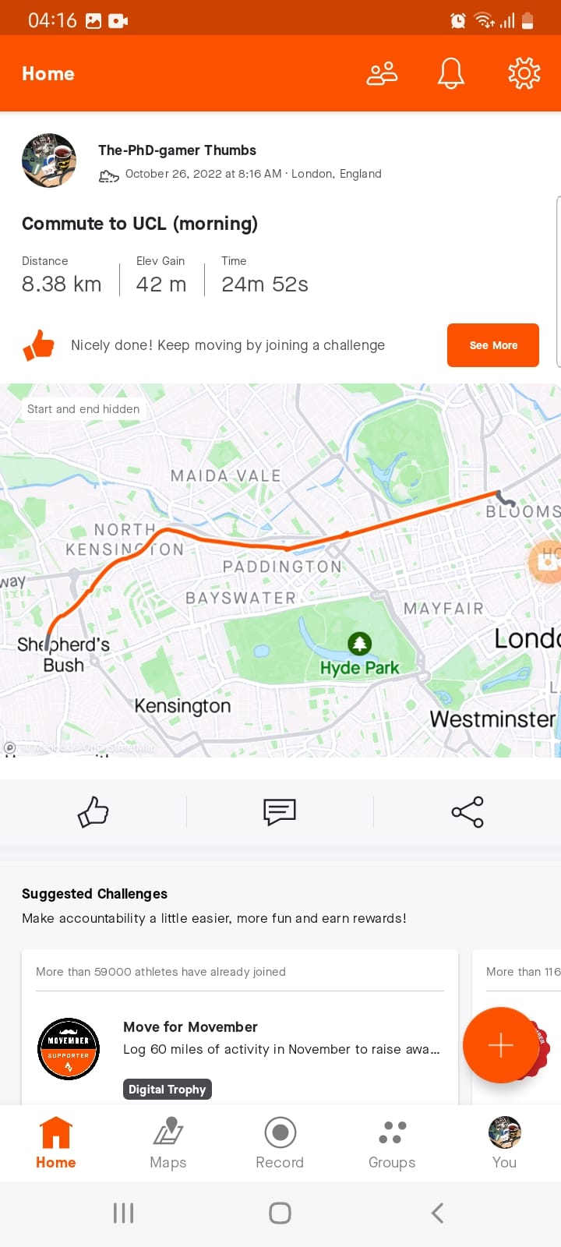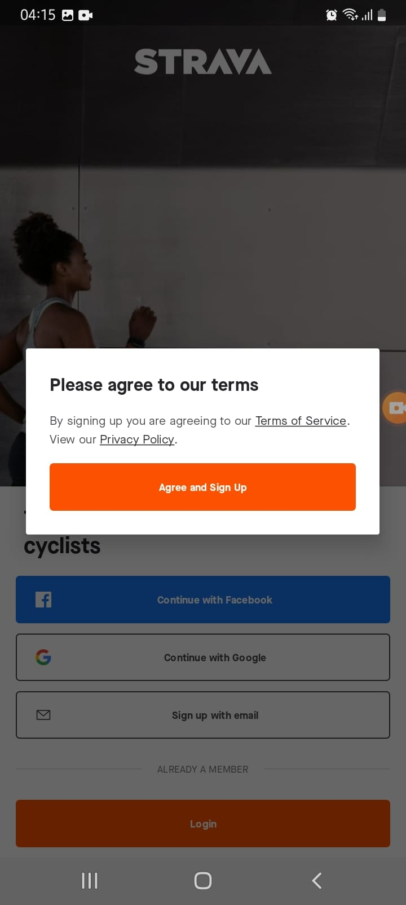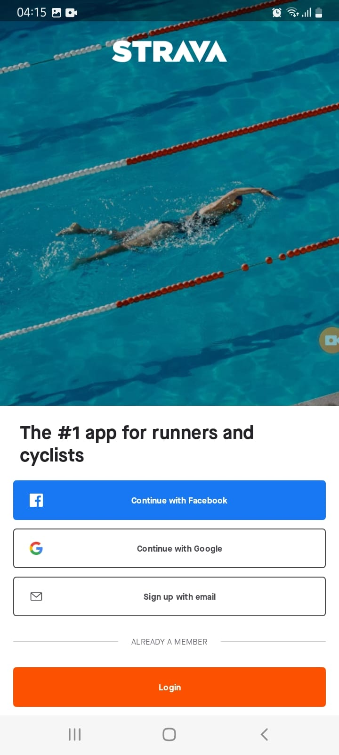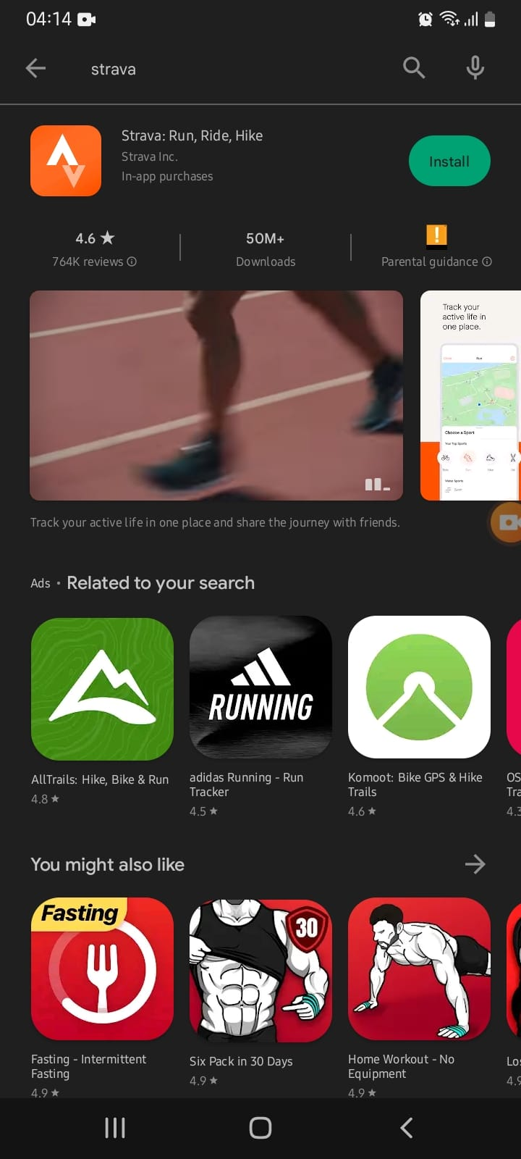

**Step 4: The application starts, and you are greeted with the home page in Strava**

**Step 1: Go to Google play store (or apple store), search “Strava” and click install, and then open.**

**Step 3: Agree to the terms and conditions by clicking “Agree and Sign Up”**

**Step 2: You will be asked to set up an account and signing via Facebook, Google or by personal email. Set up an account, as doing so will enable to download your route data later.**